The following decision tree has been created for loan approval.

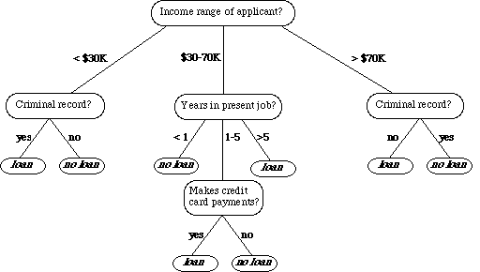

- Convert this tree to if then rules (0.5)
- Using the following testing data:

- Predict the class of each record (0.25)

 | Income range of applicant | Criminal record | Years in present job | Makes credit card payments | Class | Prediction
1 | $25K | no | 6 | no | loan
2 | $40K | yes | 2 | yes | loan
3 | $80K | no | 7 | yes | No loan
4 | $55K | no | 8 | no | No loan

- Calculate the accuracy of this model. (0.25)

- Interpret the obtained result (0.25)

- How we can improve the performance of the obtained model? (0.25)

